**ID that Skeeter!**  
Teacher handout

Target age range: 13-14 yr olds (7-9 grade)

Goal: The purpose of this activity is to educate students with some basic mosquito knowledge. This activity covers where they live, different species, and what they might transmit. Print pages 1-7 for the students. Page 8 is the answer key. Pages 6-7 are a student worksheet. Color printing is slightly important but most important for the student activity, as the mosquito descriptions describe color that will help them identify mosquitoes. If color printing is limited, print only pages 6-7 in color.

Materials: Reading exercises, videos, and short quiz.

Resources:

Zika and basic mosquito life cycle- <https://www.cdc.gov/zika/pdfs/flipbook.pdf>

West Nile virus image- <http://www.medicinenet.com/west_nile_virus_pictures_slideshow/article.htm>

Range of *Culex* mosquitoes map- <https://www.researchgate.net/publication/259386615_Vector-Virus_Interactions_and_Transmission_Dynamics_of_West_Nile_Virus>

Videos

NPR- How mosquitoes bite

* <https://www.npr.org/sections/health-shots/2016/06/07/480653821/watch-mosquitoes-use-6-needles-to-suck-your-blood>

Optional: Insects as carriers of disease (Disney, 1945) [9 minutes long]

* <https://www.youtube.com/watch?v=UoXX0DtTsw8>

**ID that Skeeter!**

Mosquitoes are everywhere! There are over 3,500 different species of mosquito around the world. Some species of mosquitoes never bite humans while others do. About 40-60 species of mosquitoes can also transmit pathogens than can cause human illness. Today we will be going over some mosquito basics: how they develop, where they develop, and differences between some important species (*Culex*, *Anopheles*, and *Aedes*).

**Mosquito lifecycle basics**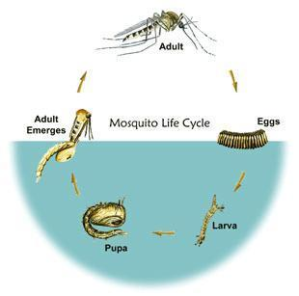

* Mosquitoes spend most of their life developing in aquatic environments.
* After hatching from eggs, the larvae feed on aquatic debris
* The larvae develop into pupae, while still aquatic, they do not feed again until adulthood. The pupal phase is typically the shortest life stage.
* Once the pupal phase is over, the adults emerge at the water surface. They spend a few hours drying their wings and then take flight!

This mosquito lifecycle applies to all types of mosquitoes, with different species preferring different aquatic environments. For example, *Aedes aegypti* can lay eggs in standing urban water (ie water in planters, tires) whereas *Wyeomyia smitthii* lay eggs in pitcher plants!

**Why do mosquitoes bite?**

Mosquitoes bite because they need to. Specifically, female mosquitoes require the protein in blood to successfully lay eggs. Male mosquitoes usually feed on nectar, as do female mosquitoes who aren’t pregnant. After mating, a female mosquito will search for a blood meal, which they get from biting a person, dog, bird or other animal. After a blood meal, the female mosquito digests it and then will find a suitable water site to lay eggs. A single female can lay up between 50-100 eggs!

**Mosquitoes and disease**

Pathogens are any type of bacteria, virus, or parasite that causes disease. A disease vector is any agent (ie mosquito, tick) that carries and transmits a pathogen (ie virus, parasite, or bacteria) to another organism. Mosquitoes that transmit pathogens are considered vectors of disease but do so inadvertently when they seek a blood meal. The mosquito injects saliva containing parasite or virus, thereby spreading the pathogen. Pathogens have developed ways to utilize mosquitoes for transmission to continue causing disease but there is some pathogen-mosquito specificity. For example, mosquitoes that can transmit malaria are unable to transmit some viruses and some mosquitoes that can transmit viruses can’t transmit malaria. There are many reasons and hypotheses on this topic like the mosquitoes immune systems and geography (where a specific mosquito lives vs. where the pathogen is found). We are going to discuss 3 different mosquito species and pathogens that they transmit.

**-** *Culex*- West Nile (virus)  
 **-** *Aedes*- Dengue, Zika (viruses)  
 **-** *Anopheles*- Malaria (parasite)

***Culex* and West Nile Virus**

West Nile Virus (WNV) pops up in the news every now and then, usually when birds are found that test positive. Birds, both alive and dead, can be routinely screened for the virus. It’s one of the reasons that you are advised to not touch dead birds. This virus usually circulates through bird populations and can be found in different areas depending on bird migration. Occasionally horses or humans can also get infected but are considered “dead end” hosts because they do not amplify the virus well enough to be infectious enough to “pass on” the virus to a biting *Culex* mosquito.

There are 2 major species of *Culex* mosquito that are native in the United States: *Culex pipiens* and *Culex quinquefasciatus*. *Culex* are large mosquitoes that are slightly yellow, with a hunched back, hind legs extended at rest (see drawing below). *Culex* larvae inhabit still, sometimes stagnant water.

WNV transmission cycle

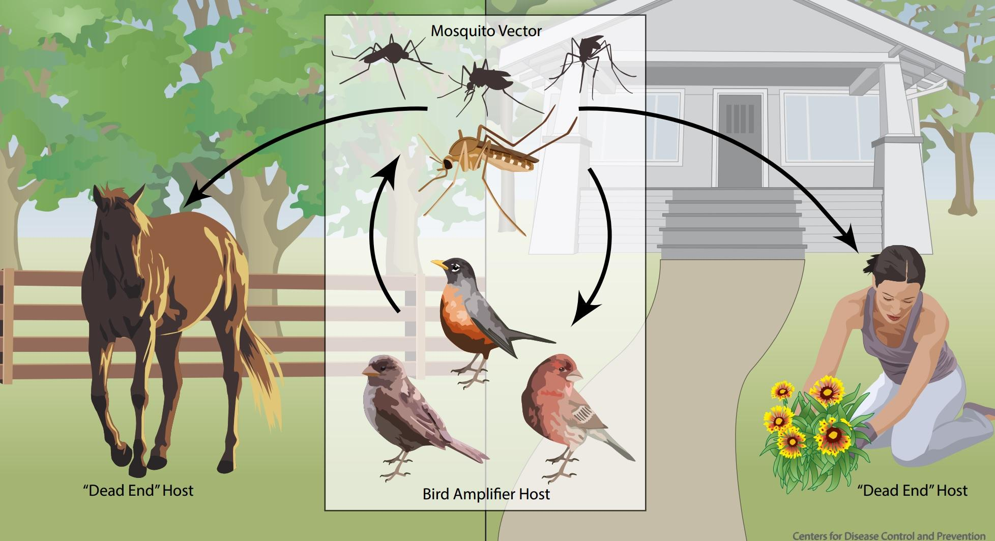

Range of *Culex* mosquitoes worldwide

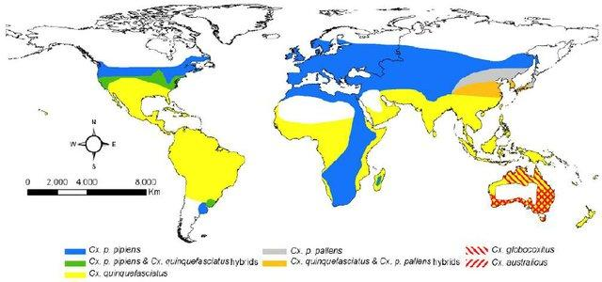

***Aedes* and Dengue, Zika (viruses)**

Dengue (DENV) and Zika virus (ZIKV) are 2 viruses transmitted by *Aedes* species mosquitoes. DENV has been a long-term problem worldwide for hundreds of years whereas ZIKV is a new emerging virus that caused an outbreak in 2016. *Aedes* species mosquitoes are considered anthropophilic, which means that they prefer humans for blood meals and are not zoophilic (preferring animals).

There are 2 major species of *Aedes* mosquito that are native in the United States: *Aedes aegypti* and *Aedes albopictus*. *Aedes* are large mosquitoes that are black with white speckling, with a hunched back that is usually parallel to surfaces (see image below). These mosquitoes are also considered very urbanized and can inhabit a variety of standing, dirty water sources (eg. plant containers, discarded tires).

*Aedes aegypti* image

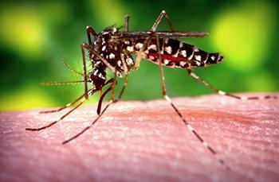

Ranges of *Aedes aegypti* and *Aedes albopictus* in the USA

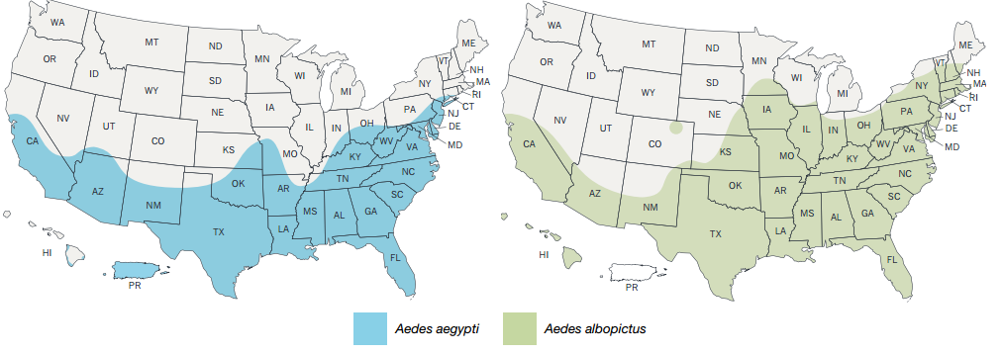

***Anopheles* and malaria (parasite)**

Malaria is a disease caused by the *Plasmodium* parasite. The parasite undergoes a complex lifecycle in both the mosquito and human for development. *Anopheles* mosquitoes are the exclusive vectors of this parasite and transmission relies heavily on the parasite developing in both the mosquito and human. The *Plasmodium* parasite must develop from one stage to another within both organisms and without successful parasite development, transmission doesn’t occur. There has been a large effort to eliminate malaria if we can break the cycle of transmission, but it has been a complex problem to solve. Malaria is considered a disease of tropical regions, but malaria used to be endemic (commonly found) in the United States, in every state but Alaska. Malaria elimination was one of the first tasks of the Centers for Disease Control and it was eliminated in the U.S. in 1951.

There are over 20 species of *Anopheles* that can transmit malaria worldwide. Anopheles are typically smaller mosquitoes that are gray-brown. They have a unique angled resting pose on surfaces that can be perpendicular at times. 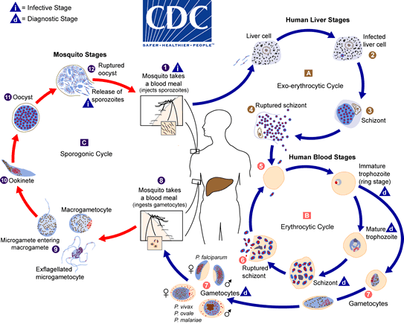

*Plasmodium* life cycle

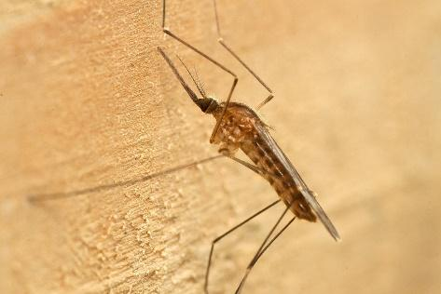

*Anopheles* global distribution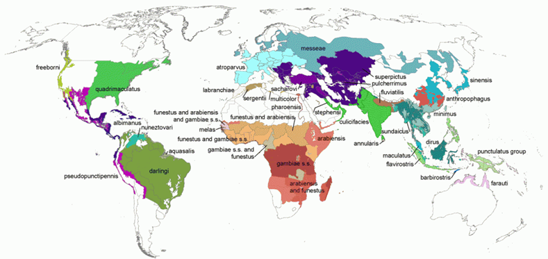

**ID that Skeeter!**  
Mosquito identification guide

**Culex/ Aedes**

**Anopheles**

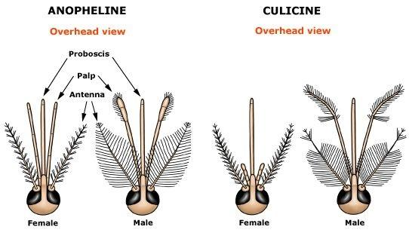

Can you see the differences between the male and female heads? The males antenna have much longer hairs and look “fluffier”. Males use these “fluffy” antenna to help them search for female mosquitoes for mating.

**Differences between *Anopheles*, *Aedes*, and *Culex* adult resting position**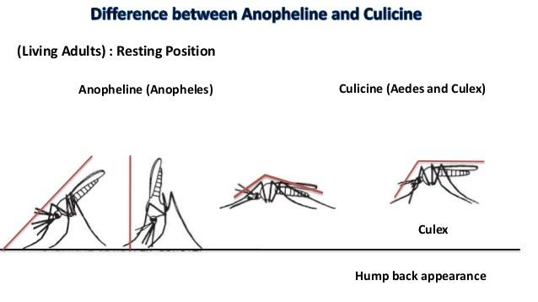

**Aedes**

**True or False??** Determine whether the following statements are true or false. If false, write down what is wrong with the statement.

1. Mosquitoes act like a needle and transmit infected blood between individuals.

________________________________________________________________________________

1. It’s not important to keep your yard and area around your house clear of standing water. Mosquitoes only lay eggs in large bodies of water.

________________________________________________________________________________

1. All mosquitoes are disease vectors.

________________________________________________________________________________

1. You can tell the sex of the adult mosquito just by looking at the head.

________________________________________________________________________________

**ID the Skeeter!** Write which species and what pathogen it can transmit

1. 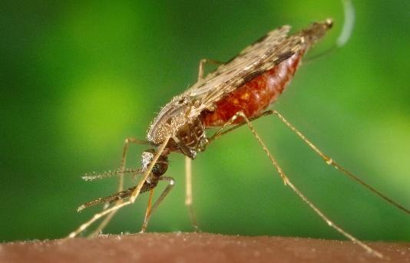 Species *__________________*

Pathogen (disease) *___________*

Sex ______________

1. 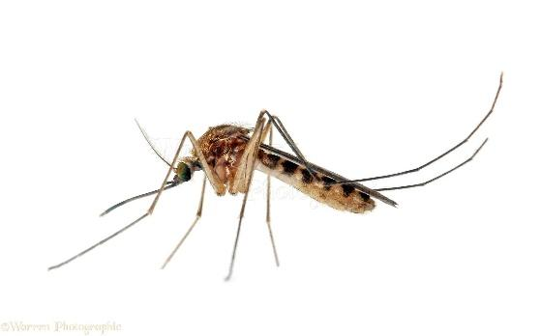 Species *__________________*

Pathogen (disease) *___________*

Sex ______________

1. 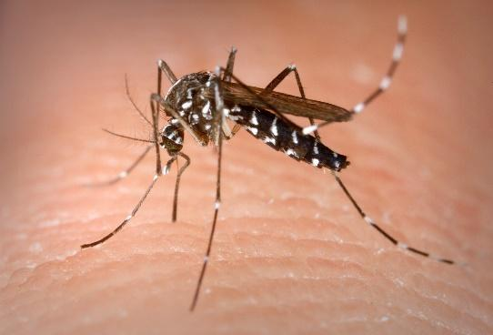 Species *__________________*

Pathogen (disease) *___________*

Sex ______________

**ID that Skeeter!**  
Student worksheet (with answers, Teacher use only)

1. Mosquitoes act like a needle and transmit infected blood between individuals.

FALSE, mosquitoes digest the blood meal and the pathogen must migrate to the salivary glands of the mosquito to be transmitted to another.

1. It’s not important to keep your yard and area around your house clear of standing water. Mosquitoes only lay eggs in large bodies of water.

FALSE, mosquitoes are very adaptable and can lay eggs in different sizes of standing or still water. It is important to regularly

1. All mosquitoes are disease vectors.

FALSE, there are many mosquitoes that are not disease vectors.

1. You can tell the sex of the adult mosquito just by looking at the head.

TRUE

**ID the Skeeter**

1. *Anopheles*, malaria (*Plasmodium* parasite), female
2. *Culex*, West Nile Virus, female
3. *Aedes*, Dengue virus, Zika virus, female